**OKRs Scorecard**

OKR grading scale:

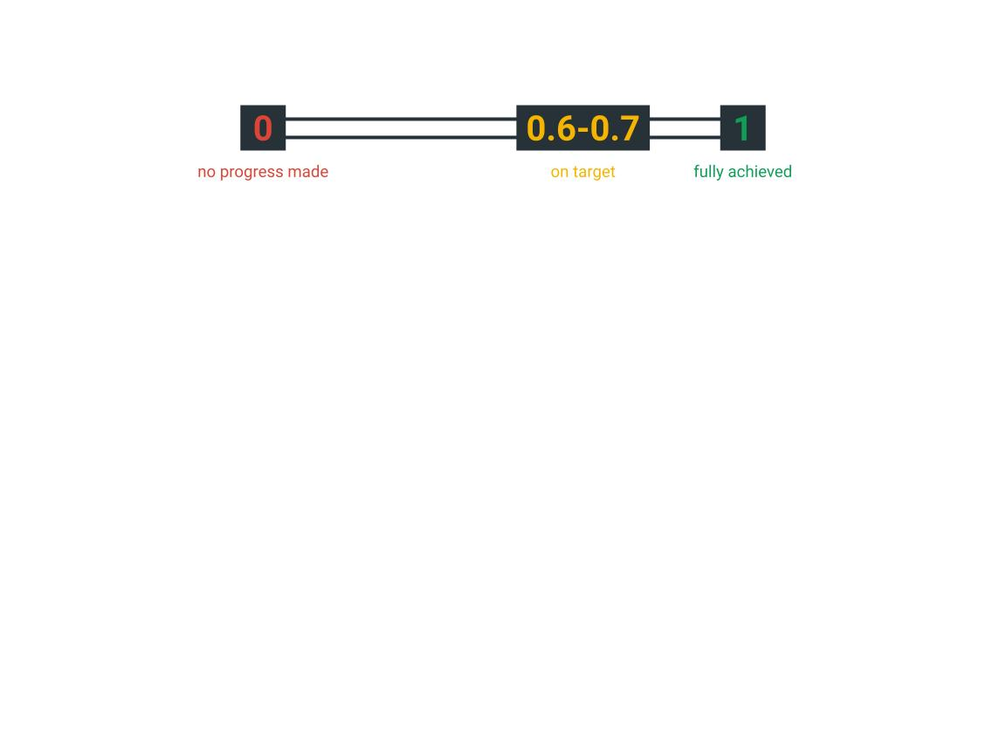

|  |  |
| --- | --- |
| **Objective** | |
| Overall score | **Have default vendors in place before launch** |
| **Key Results:** | |
|  | **Get up to 25 vendors to sign up and list products** |
|  | **Use 5-10 business owners refer 5 fellow business each with 5 products listed each.** |
|  | **Meet up 5-10 vendors personally to sign up** |
|  |  |

|  |  |
| --- | --- |
| **Objective** | |
| Overall score | **Advertise the platform before January ends** |
| **Key Results:** | |
|  | **Post 3X each on twitter, whatsapp each week about what I am building.** |
|  | **Tell 20 people with the word of mouth to get others to use the platform** |
|  |  |